**Name: Victoria Jacqueline Macías Pico**

**W O R K S H E E T S**

**NOTE:** **Your answers must be in blue and bold.**

# UNIT 10

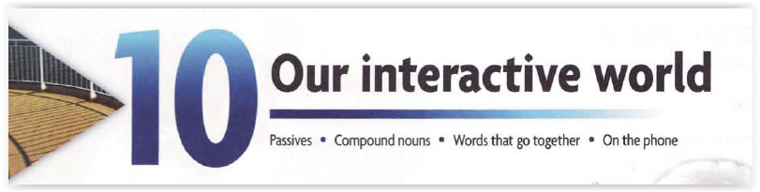

**1.Write the past participle of the following verbs:**

|  |  |  |  |
| --- | --- | --- | --- |
| INFINITIVE | SIMPLE PAST | INFINITIVE | SIMPLE PAST |
| do | Done | have | Had |
| be | Been | go | Gone |
| can | Couldn’t (past) | will | Would (past) |
| bring | Brought | fight | Fought |
| buy | Bought | think | Thought |
| catch | Caught | teach | taught |
| make | Made |  |  |
| sell | Sold |  |  |

**2. Identify the TIME TENSE of the following sentences.**

|  |  |
| --- | --- |
| **SENTENCES** | **TENSE** |
| **He reads the book** | **Present** |
| **He stole the papers** | **Simple past** |
| **I have made a mistake** | **Present perfect** |
| **I don’t blame anybody** | **Simple present** |
| **Kate is writing a book** | **Present Continuos** |
| **I will sell my car** | **Future** |

**3. Write the verb “TO BE” on the following time tenses:**

|  |  |
| --- | --- |
| **TENSE** | **VERB TO BE** |
| **SIMPLE PRESENT** | **Am/is/are** |
| **SIMPLE PAST** | **Was/were** |
| **PRESENT CONTINUOUS** | **Am/is/are-being** |
| **PRESENT PERFECT** | **Have/has-been** |
| **FUTURE** | **Will be-going to be** |

**4. Highlight the agent or SUBJECT of the following sentences.   
Then underline the OBJECT on the given line.**

|  |
| --- |
| **SENTENCES** |
| **He reads the book** |
| **He stole the papers** |
| **I have made a mistake** |
| **I don’t blame anybody** |
| **Kate is writing a book** |
| **I will sell my car** |

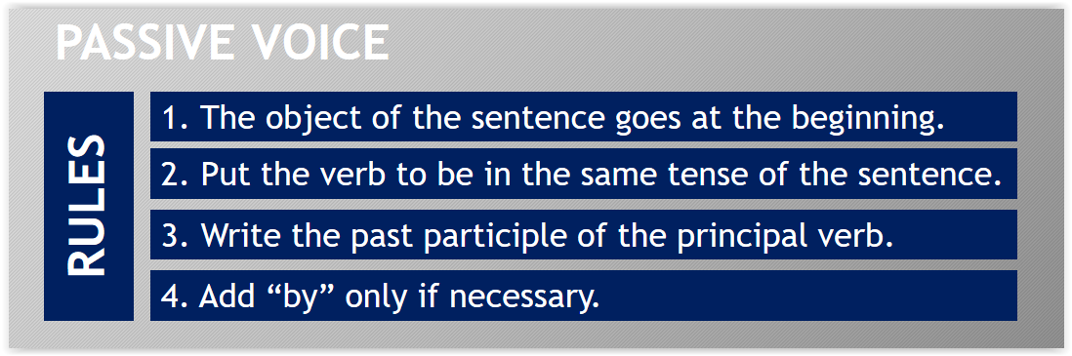

**5. Complete the chart by turning the sentences to PASSIVE VOICE:**

|  |  |  |  |
| --- | --- | --- | --- |
| **SENTENCES** |  | **PASSIVE VOICE** | |
| **He reads the book** | **🡪** | | **The book is read by him** |
| **He stole the papers** | **🡪** | | **The papers were stolen by him** |
| **I have made a mistake** | **🡪** | | **A mistake has been made by me** |
| **I don’t blame anybody** | **🡪** | | **Anybody is blamed by me** |
| **Kate is writing a book** |  | | **A book is being written by her/ Kate** |
| **I will sell my car** | **🡪** | | **My car will be sold by me** |

**6. Identify and Highlight who is really important on the following sentences. Then write if the sentences are in ACTIVE OR PASSIVE VOICE:**

|  |  |  |  |  |
| --- | --- | --- | --- | --- |
| **SENTENCES** |  |  | | |
| **Hamlet was written in 1600.** | **🡪** | | **Passive voice** |
| **Shakespeare wrote Hamlet.** | **🡪** | | **Active voice** |
| **The President is going to reduce taxes.** | **🡪** | | **Active voice** |
| **Taxes are going to be reduced.** | **🡪** | | **Passive voice** |
| **They speak German.** | **🡪** | | **Active voice** |
| **German is spoken in North Europe.** | **🡪** | | **Passive voice** |

**PRACTICE:**

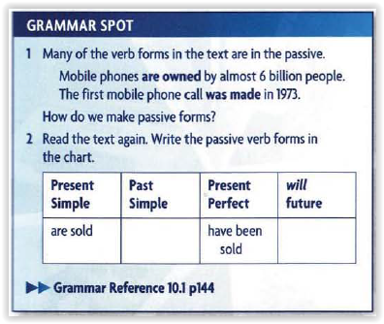

**Were sold**

**Will be sold**

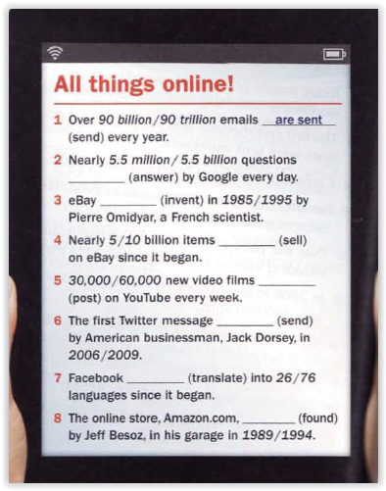

**Are aswered**

**Was invented**

**Have been sold**

**Are posted**

**Was sent**

**Has been translated**

**Was founded**

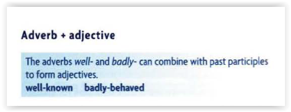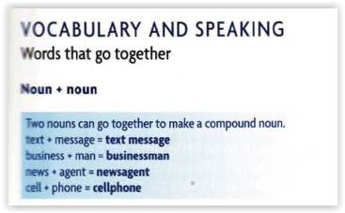

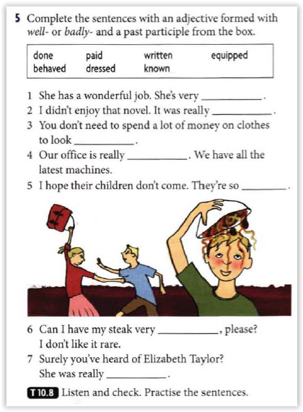

**Well-paid**

**Badly-written**

**Well- dressed**

**Well-equipped**

**Badly-behaved**

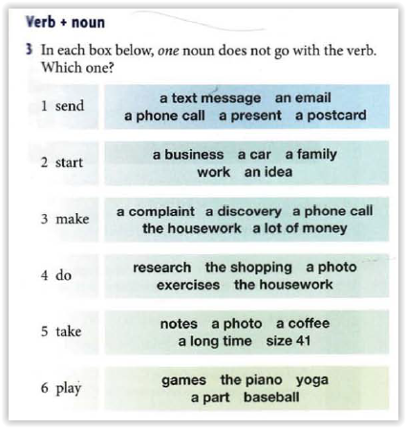

**Well-done**

**Well-know**